Flood monitoring

Algorithm:

Step 1: Sensor Deployment and Data Collection Algorithm for Data Collection:

1. Install IoT sensors in flood-prone areas, including sensors for water level, rainfall, and weather conditions.
2. Sensors continuously collect data and transmit it to a local data aggregator.
3. Ensure sensors are resilient and capable of functioning in harsh environmental conditions.

Step 2: Data Transmission Algorithm for Data Transmission:

1. Establish a communication infrastructure using a combination of cellular networks, satellite communication, or other suitable methods.
2. Sensors send data to a central control center through secure channels.
3. Implement encryption and authentication mechanisms to ensure data integrity and prevent unauthorized access during transmission.

Step 3: Data Analysis and Processing Algorithm for Data Analysis:

1. Receive and store incoming data at the central control center.
2. Use real-time data analytics and machine learning algorithms to process the data.
3. Identify patterns, anomalies, and trends in the data to assess flood risk.
4. Develop predictive models based on historical data and current conditions to forecast flood events.

Step 4: Alerting and Notifications Algorithm for Alerting and Notifications:

1. Determine alert thresholds based on the severity of flood risk.
2. Compare real-time data to these thresholds.
3. If the data indicates an imminent flood event or exceeds predefined thresholds, trigger alerts.
4. Send alerts and notifications to relevant authorities, emergency services, and residents in flood-prone areas through SMS, mobile apps, sirens, or other communication channels.
5. Customize alerts based on the severity of the flood risk to ensure appropriate actions are taken.

Step 5: Integration with Disaster Management Systems Algorithm for Integration:

1. Establish communication protocols and interfaces to integrate the IoT flood monitoring system with existing disaster management and response systems.
2. Enable seamless data sharing and coordination between the flood monitoring system and emergency services.
3. Ensure that emergency responders can access real-time data from the flood monitoring system for decision-making.

Step 6: Scalability and Cost-Efficiency Algorithm for Scalability:

1. Design the system architecture to accommodate the addition of new monitoring points.
2. Implement a scalable cloud-based infrastructure for data storage and processing.
3. Regularly assess the cost implications of system deployment and maintenance to ensure long-term cost-efficiency.

Step 7: Public Awareness Algorithm for Public Awareness:

1. Develop and implement public awareness campaigns about flood risks and safety measures.
2. Create user-friendly interfaces, such as mobile apps and websites, for residents to access real-time flood information and preparedness guidelines.
3. Utilize social media and other communication channels to disseminate information during flood events.

Step 8: Data Visualization Algorithm for Data Visualization:

1. Develop user-friendly data visualization tools for decision-makers, emergency responders, and the public.
2. Enable stakeholders to view flood data in real-time and historical contexts through interactive maps, graphs, and dashboards.

Step9:End

Flowchart:

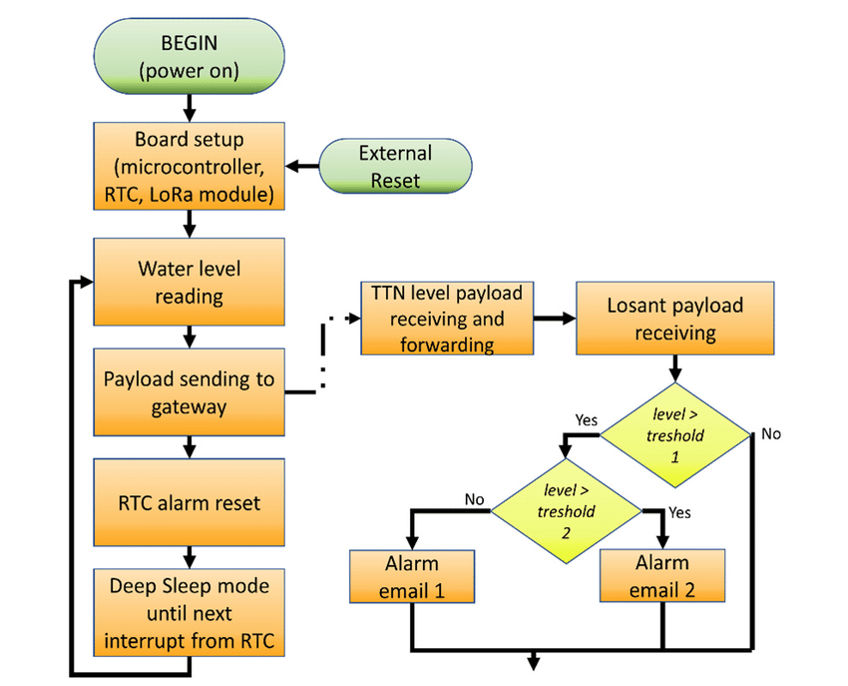

Program:

import RPi.GPIO as GPIO

import time

import datetime

# Define the GPIO pins for the ultrasonic sensor

TRIG_PIN = 18

ECHO_PIN = 24

# Set the GPIO mode to BCM

GPIO.setmode(GPIO.BCM)

# Setup GPIO pins

GPIO.setup(TRIG_PIN, GPIO.OUT)

GPIO.setup(ECHO_PIN, GPIO.IN)

# Threshold for flood detection (in centimeters)

FLOOD_THRESHOLD = 50

# Log file for flood data

LOG_FILE = "flood_data.log"

def measure_distance():

# Ensure the trigger pin is low

GPIO.output(TRIG_PIN, False)

time.sleep(2)

# Send a 10us pulse to trigger the sensor

GPIO.output(TRIG_PIN, True)

time.sleep(0.00001)

GPIO.output(TRIG_PIN, False)

# Wait for the echo signal to be received

while GPIO.input(ECHO_PIN) == 0:

pulse_start = time.time()

while GPIO.input(ECHO_PIN) == 1:

pulse_end = time.time()

pulse_duration = pulse_end - pulse_start

# Speed of sound (34300 cm/s)

# The distance is half of the total travel (to the object and back)

distance = (pulse_duration * 34300) / 2

return distance

def log_flood_status(status):

timestamp = datetime.datetime.now().strftime("%Y-%m-%d %H:%M:%S")

with open(LOG_FILE, "a") as file:

file.write(f"{timestamp} - Flood status: {status}\n")

try:

while True:

distance = measure_distance()

if distance <= FLOOD_THRESHOLD:

log_flood_status("Flood detected")

else:

log_flood_status("No flood")

time.sleep(1) # Delay between measurements

except KeyboardInterrupt:

print("Flood monitoring stopped by user")

GPIO.cleanup()